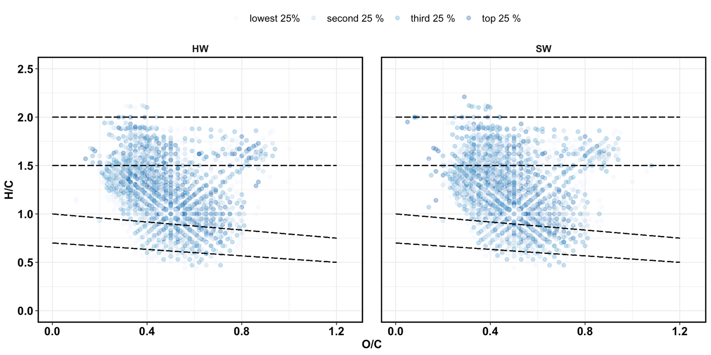**RESULTS AND DISCUSSION**

**Figure 1.** Van Krevelen diagrams for initial (pre-Fenton) SOM molecules in hardwood (HW) and softwood (SW) soils. The intensity of color represents the relative abundance of the molecules.

**Figure 2.** Van Krevelen diagrams for post-Fenton SOM molecules in hardwood (HW) and softwood (SW) soils. The intensity of color represents the relative abundance of the molecules. 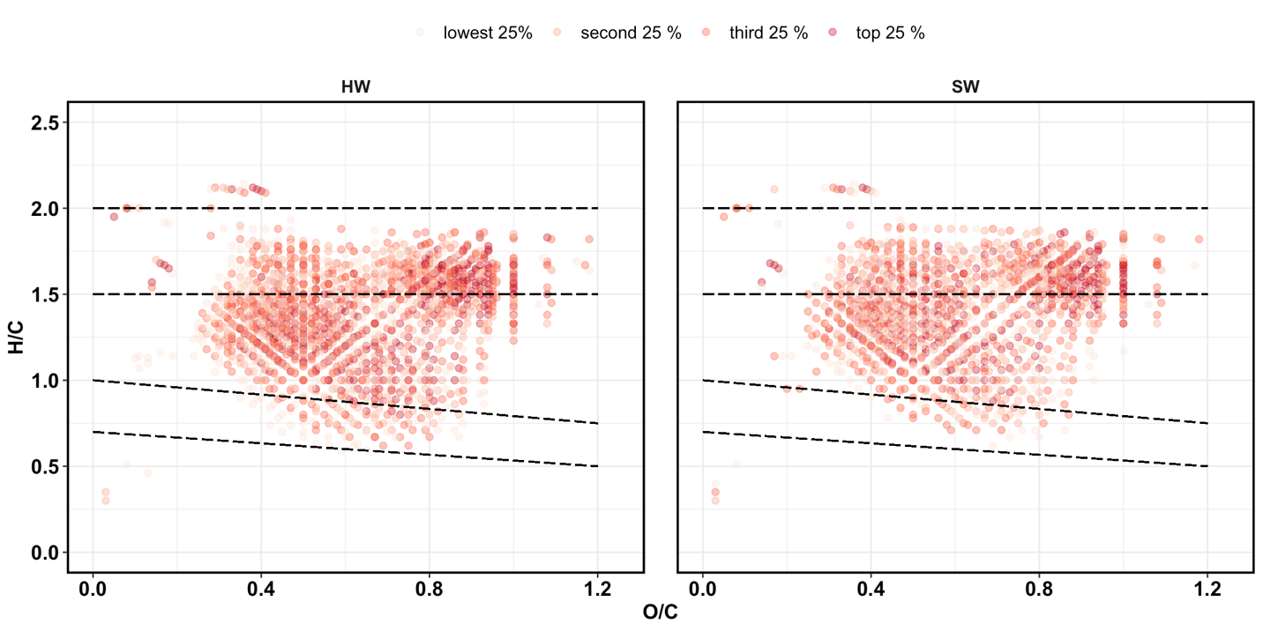

**Table 1.** Relative abundance (percentage) of groups in HW and SW SOM, for initial (pre-Fenton) and post-Fenton soils.

|  |  |  |  |  |
| --- | --- | --- | --- | --- |
|  | **HW PreFenton** | **HW PostFenton** | **SW PreFenton** | **SW PostFenton** |
| DOC concentration, mg/L | 513 ± 12 | 599 ± 9 | 656 ± 13 | 640 ± 16 |
| No. of assigned formulas | 1562 | 1675 | 1714 | 1385 |
| **element** |  |  |  |  |
| C | 20 | 20 | 21 | 19 |
| H | 26 | 27 | 27 | 27 |
| N | 3 | 2 | 3 | 2 |
| O | 10 | 12 | 10 | 12 |
| P | 1 | 1 | 1 | 1 |
| S | 1 | 1 | 1 | 1 |
| **Class %** |  |  |  |  |
| Condensed Ar | 2.5 | 0.3 | 1.87 | 0.29 |
| Aromatic | 10.12 | 3.52 | 8.87 | 1.73 |
| Lignin-like | 54.8 | 55.94 | 53.56 | 51.55 |
| Carbohydrate-like | 7.3 | 24 | 8.63 | 27.44 |
| Aliphatic-noN | 14.85 | 9.73 | 18.26 | 14.3 |
| Aliphatic+N | 10.44 | 6.51 | 8.81 | 4.69 |

Carbs and tannins increased, lignins and proteins decreased post-Fenton. Despite declines, lignin was still 50-55% of total intensity.

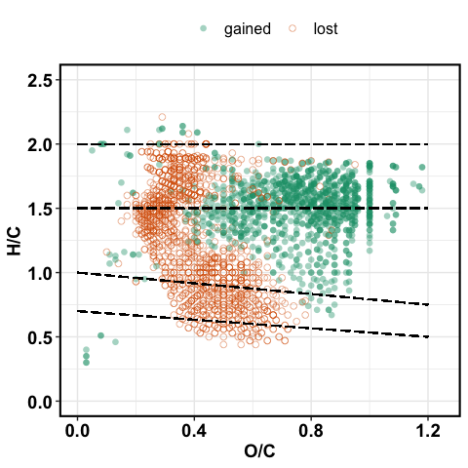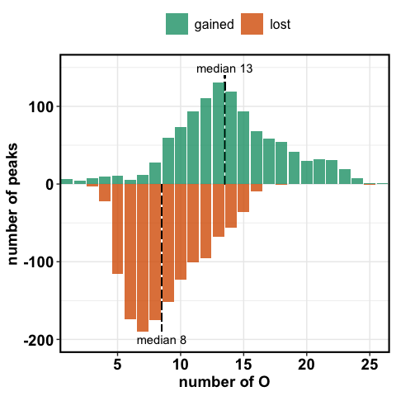

**Figure 3a. VK diagrams of molecules gained or lost following** **oxidation via Fenton reaction.**

**Figure 3b. The percentage of total peaks for the lost and newly formed formulas binned by the number of oxygen atoms for the ·OH oxidation treatment.**

**Table 2.** Relative abundance (percentage) of groups in pre- and post-Fenton extracts using NMR analysis. The ppm shift range for each group is provided in parentheses.

|  |  |  |  |  |  |
| --- | --- | --- | --- | --- | --- |
| **Functional group  (ppm shift)** | **HW** | |  | **SW** | |
| **Initial** | **Post-Fenton** |  | **Initial** | **Post-Fenton** |
| carbonyl (190-220) | 1.0 | 1.0 |  | 1.1 | 1.2 |
| carboxyl (165-190) | 12.6 | 15.1 |  | 9.4 | 10.9 |
| aromatic (112-165) | 6.2 | 5.3 |  | 5.08 | 3.5 |
| anomeric (90-112) | 11.8 | 13.7 |  | 13 | 14.5 |
| Main carb (58-112) | 52 | 46.6 |  | 58.1 | 53 |
| methoxy (54-58) | 2.9 | 4.0 |  | 2.3 | 2.9 |
| aliphatic (5-54) | 15.1 | 14.9 |  | 11.7 | 16.3 |
| total sum | 101.6 | 100.6 |  | 100.68 | 102.3 |
| total | 100 | 100 |  | 100 | 100 |

Table 3. Fenton peaks

|  |  |
| --- | --- |
| Peaks lost | 426 |
| Peaks gained | 663 |
| Peaks conserved | 821 |

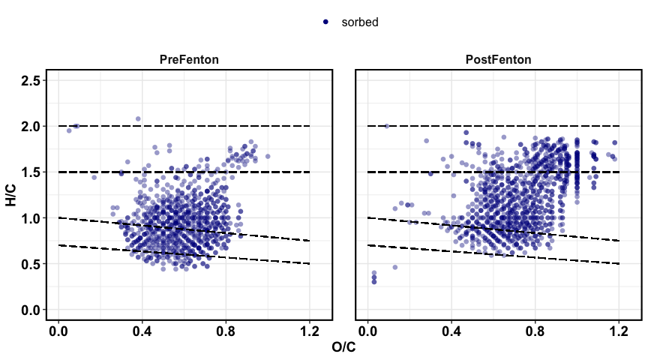

Figure 4a. Van Krevelen plot showing sorbed peaks for pre- and post-Fenton extracts.

Prefenton: median OC = 0.61

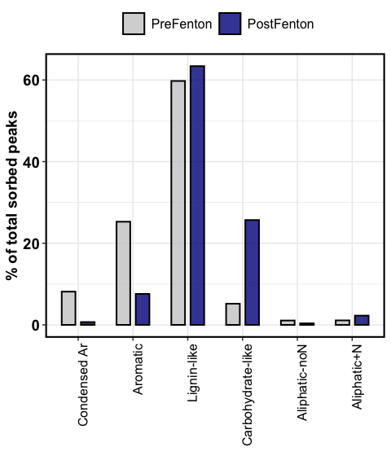Postfenton: median OC = 0.75

Figure 4b. contribution of organic classes to the sorbed fraction.



Figure 5. Carbohydrate and lignin-like peaks lost or newly detected after the Fenton reaction, as a function of oxygen atoms. The peaks lost are denoted as negative for easy comparison.

Following the Fenton oxidation, 21 carbohydrate-like peaks were consumed (median O = 11), and 347 new peaks were detected (median O = 14)

Lignin lost 405 (median O = 9), gained 316 new peaks (median O = 14).

1. **Chemical composition of native SOM**

The Van Krevelen diagrams in **Figure 1** show the distribution of molecules in the native SOM pools as defined by their H/C and O/C ratios. Both HW and SW soils were dominated by lignin-like molecules, both in terms of relative intensity (**Fig. 1**), and number of peaks (**Table 1**). In general, SOM composition did not differ between forest types, with ~ 76 % of peaks (1416) shared by both hardwood and softwood soils.

1. **·OH Oxidation Effects on Extract DOC Concentration and Composition.**

The chemical composition of DOC extracts was substantially altered by the Fenton oxidation for both HW and SW soils (**Fig. 2, Table 1**), although the overall DOC concentrations did not differ significantly between pre- and post-Fenton extracts (**Table 1, p = XXXX**). This indicates that our one-hour Fenton treatment resulted in partial oxidation of the DOM components, rather than complete oxidation to CO2.The van Krevelen diagrams also show that that there was a high degree of similarity for the HW and SW extracts, indicating that stand vegetation might not strongly affect SOM response to hydroxyl ion oxidation.

Overall, molecules with lower O/C ratios, typically considered to be polyphenolic and condensed aromatic were preferentially lost, whereas the newly **detected** molecules generally had H/C > 1.0 and O/C > 0.5, typically considered to be carbohydrate-like **(Fig. 3a)**. Our data also suggest that the ·OH radical reaction was preferentially consuming DOM molecules with ≤ 8 O atoms and the newly detected molecules had ≥ 13 O atoms (median values, **Fig. 3b**). This effectively raised the median number of O atoms to 11, compared to 9 for pre-Fenton extracts. This shift to higher O-containing molecules is likely to impact DOM reactivity with soil components, in terms of lability and sorption onto mineral surfaces. In this experiment, we investigated the latter, by sorbing these extracts onto goethite, discussed below.

* 1. **SOM composition using NMR.**

We used solid-state 13C NMR to confirm the formation of “new” carbohydrate molecules, and the relative abundances of functional groups are reported in **Table 2**. Carbohydrates accounted for nearly 50 % of total abundance by NMR analysis, and showed no change in pre- vs. post-Fenton extracts (**Table 2**). This is an interesting contrast to the FTICR results discussed above, and these differences may be explained by (a) data handling and (b) sample processing techniques for the two methods. The FTICR-MS relative abundance in **Table 1** was computed using the number of peaks and is therefore only a qualitative approach, compared to the more quantitative NMR data, calculated using peak intensities.

Second, the negative spray ESI technique used for FTICR-MS is biased toward more aromatic molecules like lignin, whereas aliphatic molecules like carbohydrates are typically underrepresented (Ohno et al. 2016). **Figure 3a** shows that many polyphenolic (lignin-like) peaks were lost due to the Fenton oxidation, allowing for more aliphatic (carbohydrate-like) peaks to be ionized and subsequently detected in the post-Fenton extracts. NMR, on the other hand, does not involve such an ionization process, and is therefore unlikely to show these biases. Thus, in this paper, we use FTICR-MS only to determine the presence/absence of peaks, and NMR for a more quantitative understanding of SOM composition.

1. **Adsorptive fractionation by goethite**

We used a presence/absence technique to identify the molecules that were sorbed onto goethite. Peaks that were present in the pre-Goethite extracts but absent post-Goethite were completely sorbed, henceforth referred to as “sorbed”. Peaks that were present in both pre- and post-Goethite extracts were, in theory, either unbound or partially sorbed. Sorbed molecules had a median O/C of 0.67 and median O of 12, whereas the unbound and partially sorbed molecules had a median O/C of 0.46 and median O of 9.

SOM sorption to mineral surfaces has been shown to follow a multi-layered “onion” model, with high-O aromatic and lignin-like molecules being preferentially adsorbed via ligand exchange and hydrophobic interactions (Leinemann et al. 2018; Coward et al. 2019). In contrast, carbohydrate-like and aliphatic molecules are less preferentially sorbed, making them more available for microbial uptake and degradation. Consistent with this, in the pre-Fenton extracts, ~90 % of the sorbed peaks were attributed to complex aromatic molecules (condensed aromatic, aromatic, lignin-like), with lignin-like peaks accounting for ~ 60% of total sorbed peaks (**Fig. 4b**). Although lignin did contribute ~63 % of the total sorbed peaks, the contribution of aromatic and condensed aromatic peaks was greatly reduced. Instead, carbohydrate-like molecules contributed ~25 % of the sorbed peaks, a 5-fold increase from the pre-Fenton extracts.

1. **Conclusions/ Implications**

While the relative proportion of lignin peaks did not change with oxidation, our results indicate that low-O lignin peaks were replaced by high-O lignin peaks, which altered competitive adsorption patterns for the carbohydrates as well.

——— x ———

——————

**Beyond this are random scraps of text that are not part of the manuscript. Do not review/edit.**

have demonstrated preferential adsorption of high-O aromatic and lignin-like molecules to Fe-minerals via ligand exchange and hydrophobic interactions.

Mineral sorption protects SOM from decomposition. Sorption occurs in layers, with lignin preferentially adsorbed to the mineral surfaces. We demonstrate that the hydroxyl oxidation altered the SOM chemistry such that carbohydrates were preferentially sorbed. Indicating that oxygen plays a very important role in the sorption to Fe.

Following the method of (Young et al. 2018), we classified the SOM pool into seven categories (“most sorbed” to “most unbound”) to determine potential patterns of selective adsorption. We subtracted the percent abundance of each molecule in the post-Goethite extract from the pre-Goethite extract. The resultant VK diagrams **(Fig. 4)** show clear patterns of sorptive fractionation. Across all soil extracts, low-O, high-H molecules (protein-like) remained largely in solution and did not bind to the goethite, whereas the high-O molecules showed higher tendency to bind to goethite. In the post-Fenton extracts, carbohydrates appeared to sorb more strongly.

The post-Fenton extracts had more detectable high-O and high-H carbohydrate-like molecules **(Fig. 2)**, and this was also reflected in the molecules adsorbed to goethite.

A comparison of pre-and post-Goethite solutions indicated the formation of ~1228 (average of 1194 SW and 1263 HW) new molecules, mostly with O/C ratios < 0.5 and H/C ratios > 1.0 **(Fig. 7)**. These molecules did not differ by Fenton treatment (pre – vs. post-Fenton) or forest type (HW vs. SW).

This is consistent with previous research that has found SOM adsorption was controlled by acidic functional group interactions with iron hydroxides (REF).

Since adsorption onto mineral surfaces typically offers some physical protection to organic molecules, we can assume that the carbohydrates would be less susceptible to mineralization than the lignin molecules. These patterns of adsorption are interesting because aromatic/ polyphenolic compounds typically bind more strongly to mineral surfaces. These molecules make up the first layer of the onion model of SOM sorption.

Studies have described the “onion” model of adsorption, with aromatics forming the first layer, lignins forming the second layer, and simple aliphatics forming the third layer. Since we shook our DOM extracts with goethite for 48 hours, that should theoretically be sufficient time for multiple layers of molecules to sorb onto the mineral surface. (Coward et al. 2019) demonstrated that within two hours, multiple groups of molecules were adsorbed.

These adsorption patterns of pre- vs. post-Fenton extracts may be explained by the oxygen content of the molecules, which has been linked with sorption strength (REF). Consistent with this, our data suggest that molecules with **> 12 O atoms** (median value) were typically sorbed onto goethite, and molecules with **< 7 oxygen atoms** remained generally unbound. **Fig. 8** shows the relative abundance of molecules with varying oxygen contents in the pre-Goethite extracts. We show only the four classes – lignin, carbohydrates, proteins, and tannins – that made up the top 75-80 % of the SOM pool **(Table 1)** and also showed the most siignificant conttibution to the sorbed and unbound fractions post-Goethite **(Fig. 6)**. **Fig. 8** indicates a substantial change in the number of oxygens post-Fenton. The post-Fenton pool showed a greater abundance of carbohydrates and high-O tannins. Low-O lignins and proteins decreased, but intermediate/high-O lignins were unchanged. These changes in oxygen distribution could explain the adsorption patterns. Proteins are primarily < 12 oxygens and therefore not very strongly sorbed to goethite. There seems to be some competitive adsorption of carbs and tannins vs. lignins.

It is unlikely that the shift is merely a reflection of shift in relative abundance of the different groups. Although the abundance of lignin did decline post-Fenton, it still accounted for 50 % of the total SOM pool. This indicates that the O state plays an important role.

For pre-Fenton SOM, medium-O aromatic and polyphenolic molecules were the most sorbed. For post-Fenton SOM, it was mostly high-O molecules, reflecting the changed nature of the SOM pool. for all solutions, the unbound fraction was low-O molecules with high H/C ratios.

**Figure 6.**

In the native SOM pool, lignin accounted for 60% of the total sorbed compounds. Consistent with previous research.

Post-fenton, carbs were more adsorbed than lignins. **Carbs are more “protected”**?

Greater abundance of carbohydrates and high-O tannins post-Fenton. Low-O lignins and proteins decreased, but intermediate/high-O lignins were unchanged. The distribution of oxygens could explain the adsorption patterns. Proteins are primarily < 12 oxygens and therefore unbound. Competitive adsorption of carbs and tannins vs. lignins. Different mechanisms of binding?

Look at the characteristics of the lignins lost and gained. Oxygens, mass, N.